IELTS Writing
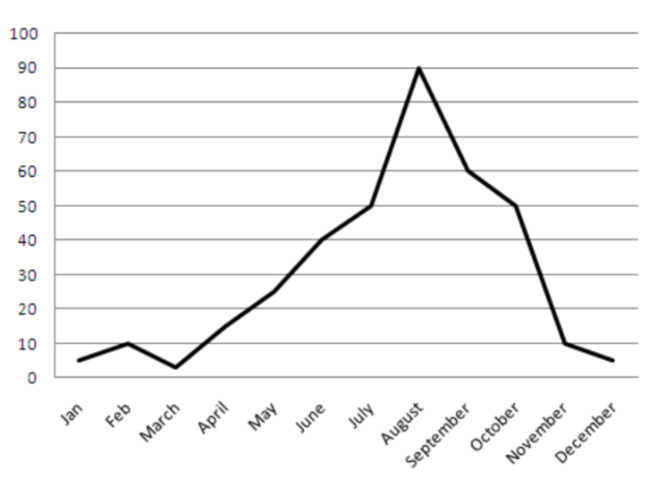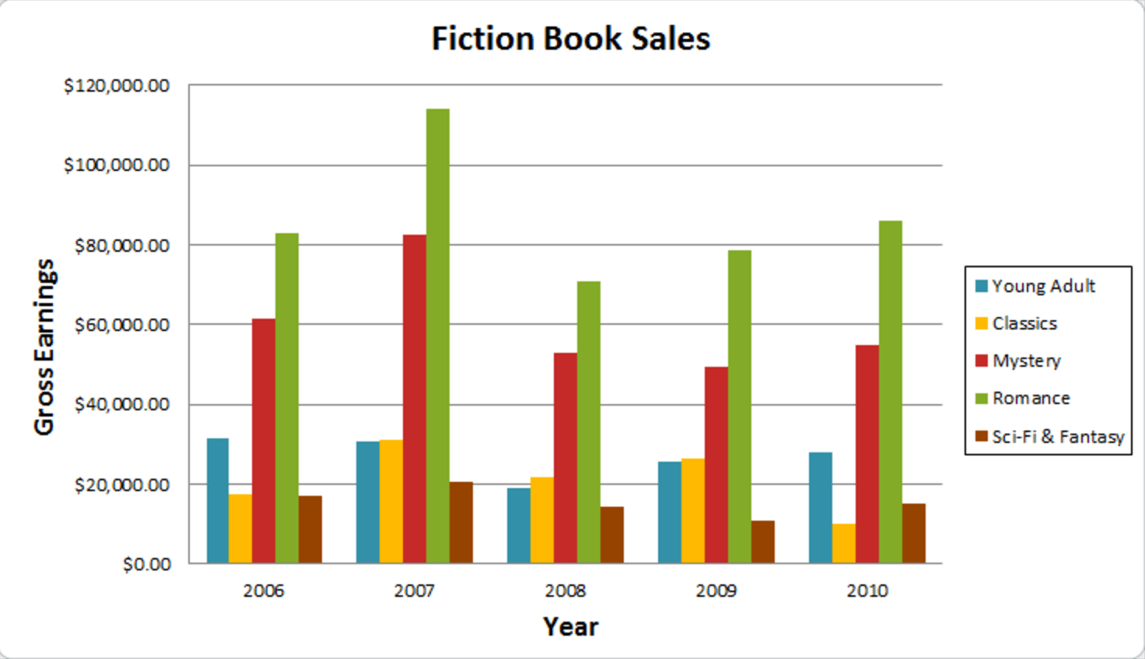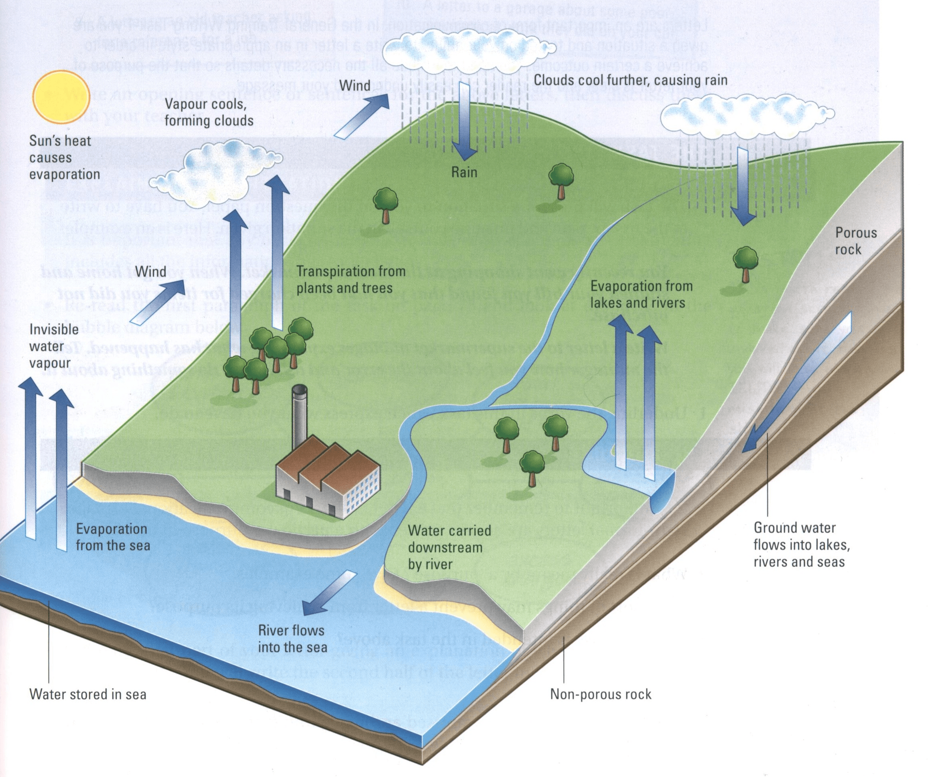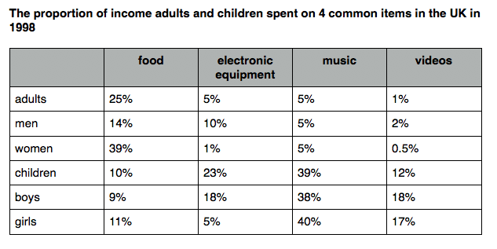

20 min
150 words
A VARIETY OF COMPLEX GRAMMATICAL STRUCTURES
- conditionals  - tenses  - collocations  - modals  - phrasal verbs  - inversion | - connectives  - idioms  - proverbs  - questions  - gerund  - passive
- Task
- Organization
- Grammar
- Vocab

